P. R. GOVERNMENT (A) COLLEGE, KAKINADA
DEPARTMENT OF COMPUTER SCIENCE
Report on LLR Mela

An LLR mela was organised in P.R.Government College on 27-11-2017 to create awareness among students regarding driving license. Dr.C.Krishna, Principal of the college presided over the program.
Kakinada city mayor Smt.Sunkara Pavani was the chief guest. She expressed her personal experience as a mother who worries about child’s safety. So she instructed all the students to remember their parents while driving on the road.
Traffic D S P K.V.Satyanarayana was a guest to the program. He explained the students all the traffic rules and the offences made by students and their consequences .
The RTO Kakinada Mr.Ram Prasad was also a guest to the program .He told the students the importance of driving license and insuarance .he explained the real life situations of some families who have lost the earning member of the family in accidents.
Motor vehicle inspector G.V.Narasimha Rao was another guest to the program. He explained the students about the importance of registration for license and traffic rules.
Salagrama Lakshmi Prasanna , 36 ^{th} ward corporate , Godi Satyavati , 41 ^{st} ward corporate, T.Varaprasad, Vice-Principal, P.R.Govenment College, Dr.K.V.Sobharani, Women empowerment cell conveynor, Police Staff ,students have participated in this program and made it a grand success.

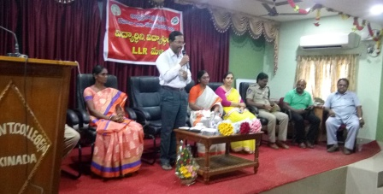
Principal C.Krishna garu addressing the gathering
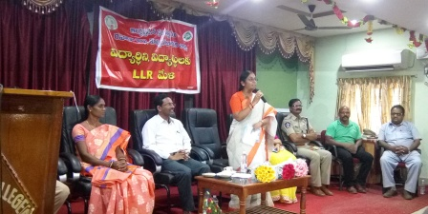
Mayor Sunkara Pavani explaining the importance of driving license
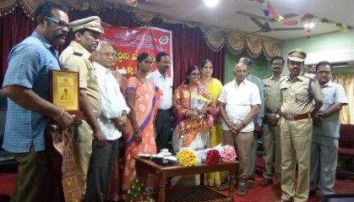
Felicitation of major by principal & Road and Transport Authority

